Detecting and Mitigating Intersectional Racial Bias in Pulse Oximetry and in Clinical Machine Learning Models
Tomer Natan, Machine Learning in Medicine, MIMIC-IV v3.1
Abstract
Pulse oximetry (SpO2) is the standard non invasive estimate of blood oxygen in intensive care. It is known to over read the true arterial saturation (SaO2) in patients with darker skin, which produces "occult hypoxemia", meaning a dangerously low oxygen level that the device fails to show. We asked three things. First, whether this bias appears in a large ICU database. Second, whether it compounds across the intersection of race and sex. Third, whether it carries over into machine learning risk models and whether it can be reduced. From MIMIC-IV we paired 15,160 arterial SaO2 measurements with the nearest SpO2 reading within 10 minutes, in the first 24 hours of the ICU stay. Occult hypoxemia was about 3 times more common in Black than in White patients (11.3% vs 3.2%, risk ratio 3.53, p<0.001), and it was significant for both women and men. A logistic regression model that used SpO2 inherited this bias, with a false negative rate of 0.47 for Black patients against 0.35 for White patients. Adding unbiased vital sign features was the main thing that helped, since the Black to White gap fell from 0.12 to 0.04, and an adversarial debiasing network gave the best balance, keeping high discrimination (AUC 0.82) with a small gap and without using race at decision time. An error analysis showed that the baseline failed on exactly the occult cases, since the missed patients had a much larger device over-read (median 16 against 5 points) and were mostly severely hypoxemic. The subgroup differences pointed in the expected direction but the sample was too small to reach significance. In short, a simple device carries a measurable intersectional racial bias that reaches clinical machine learning, and feature enrichment together with a race blind model can reduce it on ordinary hardware.

1. Introduction
Blood oxygen saturation can be measured in two ways in the ICU. One way is the fingertip pulse oximeter (SpO2), which is continuous and non invasive. The other is an arterial blood gas sample (SaO2), which is invasive but gives the true value. The pulse oximeter estimates saturation from light passing through the skin, and it was calibrated mostly on light skinned people, so it tends to read too high in patients with darker skin. The dangerous result is occult hypoxemia, a reassuring SpO2 reading that hides a truly low SaO2 and can delay oxygen therapy.
This is not only a device problem. Many clinical risk models use SpO2 as an input feature, so if the input is biased the model can take on that bias and apply it at scale. Two points are not well covered in the existing work. The first is how the bias behaves across the intersection of race and sex rather than race on its own. The second is whether it spreads into machine learning models, and whether it can be reduced without using race when the model makes a decision.
This work makes three contributions. We measure intersectional bias (race together with sex) in pulse oximetry on a large public ICU dataset, and we recover the magnitude reported in earlier single axis studies. We then show that a model that relies on SpO2 inherits the bias. Finally we show that enriching the feature set with unbiased physiological signals, together with an adversarial debiasing model, reduces the gap and still runs on a normal laptop.

2. Related work
Earlier work documents the device bias and its clinical effects quite well, but it rarely looks at intersectional subgroups, at how the bias spreads into models, or at how to reduce it. Table 1 summarizes the main studies we relied on.
Study | Main finding | Data and scope
Sjoding et al., 2020 (NEJM) | Pulse oximetry over reads about 3 times more occult hypoxemia in Black patients (11.4% vs 3.6%). | 2 US hospitals
Wong et al., 2021 (JAMA Netw Open) | Occult hypoxemia is more common in Black, Asian and Hispanic patients, and is linked to higher mortality and organ dysfunction. | 87,971 patients, 215 hospitals
Valbuena et al., 2022 (BMJ) | Reproduced the bias in general inpatients, with occult hypoxemia 19.6% in Black vs 15.6% in White patients. | VHA, multicenter 2013 to 2019
Meta-analysis, 2024 (J Gen Intern Med) | Systematic review showing consistent racial gaps in occult hypoxemia and worse outcomes. | Meta-analysis
Race based correction, 2022 (arXiv) | A race based correction does not fix the bias, because skin tone is continuous and not a category. | Methods analysis
Obermeyer et al., 2019 (Science) | Racial bias spreads into clinical algorithms through biased data and proxy labels. | US insurance data
Table 1. Summary of the main literature on pulse oximetry racial bias and algorithmic fairness.
The common gap is clear. Prior studies look at race alone, they rarely test whether the bias spreads into models, and they leave open whether mitigation can work. This project addresses all three.

3. Data and methods

3.1 Dataset and pairing
We used MIMIC-IV v3.1, a large public ICU database with about 95,000 stays. For each arterial SaO2 measurement (blood gas, itemid 50817, restricted to arterial samples by requiring a co measured pO2 above 50 mmHg) in the first 24 hours of an ICU stay, we attached the nearest pulse oximeter SpO2 reading (itemid 220277) within 10 minutes, using a nearest in time join. Race, sex and age came from the admissions and patients tables. This gave 15,160 paired readings.

3.2 Preprocessing
The most important preprocessing step is the arterial filter. Without it the SaO2 column mixes in venous samples (median around 67%) that would inflate the apparent hypoxemia. After we keep arterial samples only (pO2 above 50) the median is about 97%, which is what we expect. We also dropped values outside a physiological range (SpO2 between 50 and 100, SaO2 between 0 and 100). The extraction went from 60,331 raw SaO2 measurements to 38,869 arterial ones and finally to 15,160 paired readings. We defined occult hypoxemia, following the literature, as a SaO2 below 88% within the reassuring SpO2 band of 92 to 96%.
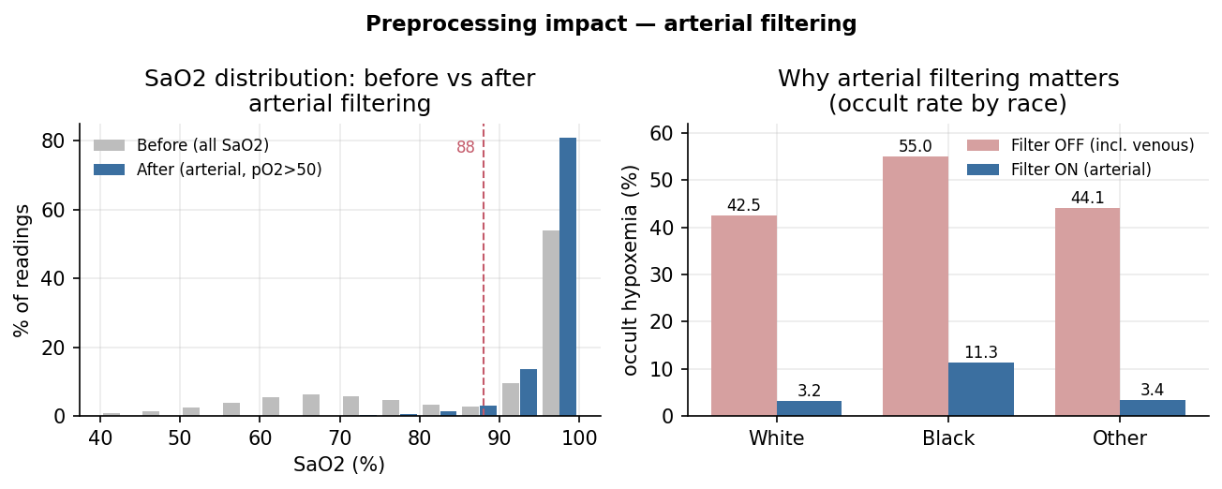
Figure 1. Effect of preprocessing. Left, the SaO2 distribution before and after the arterial filter. Right, the occult hypoxemia rate by race with the filter off versus on. Without the filter the analysis is invalid, giving 42 to 55% spurious cases.

3.3 Outcome and fairness metrics
For the device bias analysis the outcome is occult hypoxemia as a binary label. For the modeling experiments the target is true hypoxemia, a SaO2 below 88%. We report discrimination as AUC and PR-AUC. We report fairness as the false negative rate (FNR), which is the share of truly hypoxemic patients that the model misses, broken down by race, plus the Black to White FNR gap. We add bootstrap confidence intervals and per group calibration to check how solid these numbers are.

3.4 Models
The baseline is a class balanced logistic regression that predicts true hypoxemia from SpO2, age and sex. It is simple, easy to read and common in the literature, and we compare it against the naive clinical rule of flagging hypoxemia when SpO2 is below 92. To reduce the inherited bias we tried two methods. The first is group by label reweighting. The second, which is the approach we propose, is adversarial debiasing. A shared encoder feeds a predictor head and a race adversary head, connected through a gradient reversal layer, so the learned representation becomes hard to use for guessing race. Race is used only during training and never when the model makes a decision. We also enriched the feature set with vital signs measured close in time (heart rate, respiratory rate, mean blood pressure and temperature), so the model has unbiased signals to lean on instead of SpO2 alone. We used scikit learn and PyTorch, and training took a few seconds on a normal laptop (Apple M1 Pro, 32 GB RAM, no GPU).
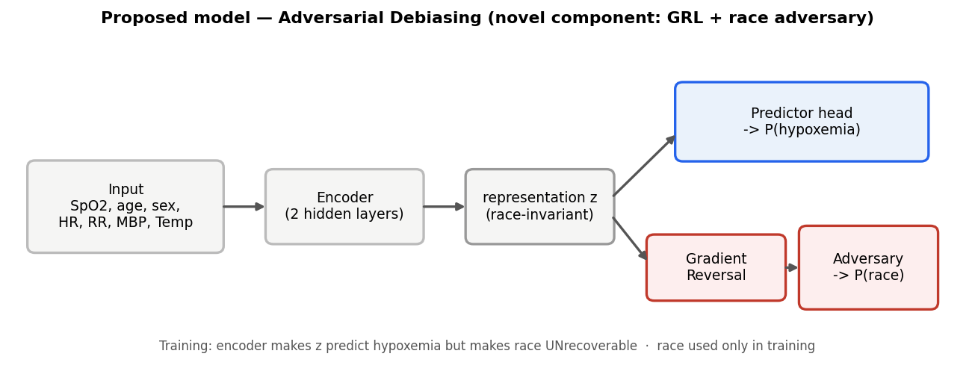
Figure 2. The proposed model. A shared encoder feeds a predictor head, and a race adversary is connected through a gradient reversal layer, which is the new component. This pushes the representation to be race blind.

4. Results

4.1 Intersectional device bias
Occult hypoxemia was clearly and significantly more common in Black patients, 11.3% against 3.2% in White patients, a risk ratio of 3.53 with p<0.001. This closely matches Sjoding et al. (11.4% against 3.6%), which gives us confidence that the pipeline is correct. The intersectional view confirms the bias in both sexes. Black women were at 10.1% against 3.2% for White women (p=0.002), and Black men were at 12.2% against 3.2% for White men (p<0.001). Race is the stronger axis.
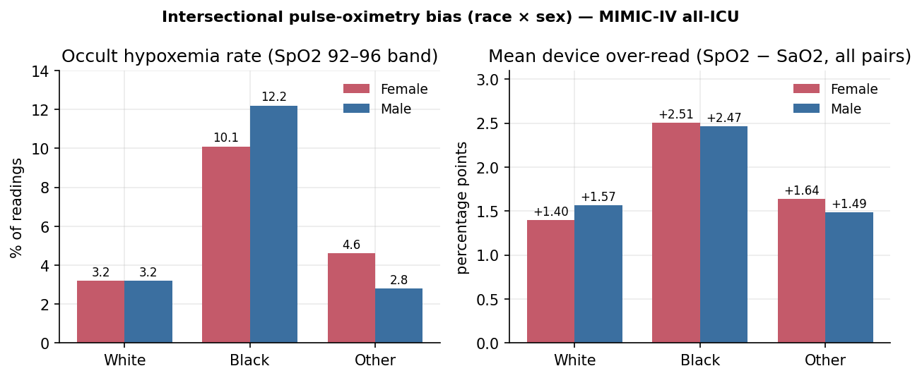
Figure 3. Intersectional pulse oximetry bias by race and sex. Left, the occult hypoxemia rate. Right, the mean device over read (SpO2 minus SaO2). The bias is large and significant for both Black women and Black men.

4.2 The bias spreads into the model
The logistic regression baseline reached an AUC of 0.762 and did much better than the naive rule, but it took on the racial bias. Its false negative rate was higher for Black patients (0.47) than for White patients (0.35), which mirrors the naive rule (0.76 against 0.65). A model that trusts a biased input misses more high risk patients in the affected group.
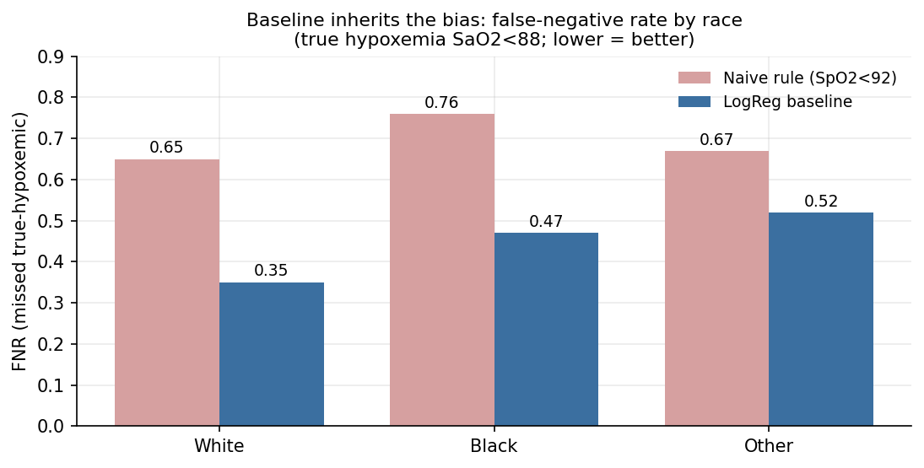
Figure 4. The baseline takes on the bias. False negative rate by race for the naive rule and for the logistic regression model, where lower is better.

4.3 Mitigation
Two things came out of this. The first is that feature enrichment with unbiased vitals was the main lever. Just adding heart rate and respiratory rate cut the baseline Black to White FNR gap from 0.12 to 0.04, because the model no longer leans only on the biased SpO2. The second is that adversarial debiasing gave the best balance, with the highest discrimination (AUC 0.820) and a small gap (0.06), and without using race at decision time. Reweighting raised the AUC (0.826) but did not help fairness (gap 0.15), which tells us it is not the right tool for a bias that lives in the input. Table 2 lists the results.
Model | AUC | FNR gap (Black minus White)
Baseline (thin features) | 0.762 | 0.12
Baseline (enriched) | 0.776 | 0.04
Reweighting (enriched) | 0.826 | 0.15
Adversarial (enriched) | 0.820 | 0.06
Table 2. Model comparison. Discrimination (AUC) and the Black to White false negative rate gap.
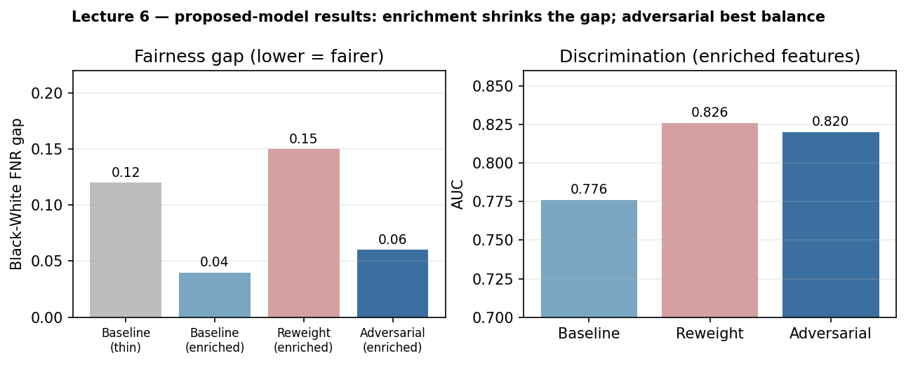
Figure 5. Proposed model results. Left, the Black to White FNR gap shrinks mostly with feature enrichment. Right, the AUC of the enriched models.

4.4 How solid the model results are
Because the number of truly hypoxemic patients in each subgroup is small, for example 17 Black patients in the test set, the model level FNR gap is not statistically significant. A bootstrap 95% confidence interval for the gap runs roughly from minus 0.2 to plus 0.3 and crosses zero. The device level bias in Section 4.1, measured over thousands of readings, stays highly significant. Calibration is similar across racial groups, with an ECE around 0.34 to 0.37, so there is no calibration gap between groups. The absolute calibration is poor, which is expected from class balanced training and does not affect the ranking and threshold based results above.
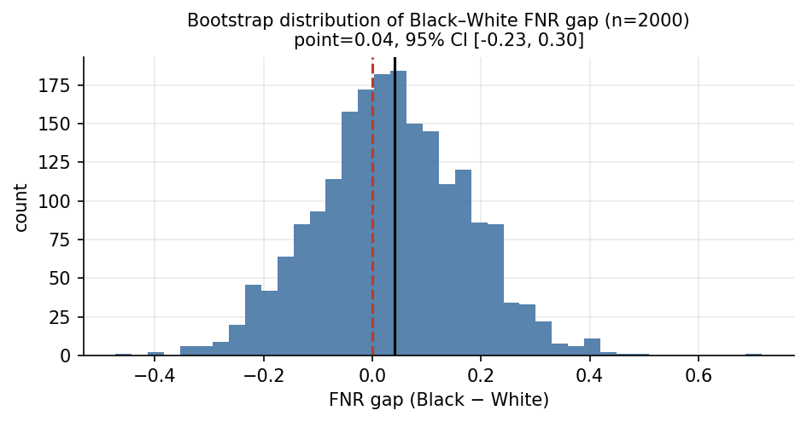
Figure 6. Bootstrap distribution of the Black to White FNR gap. The interval crosses zero, so the model level gap is not statistically significant.
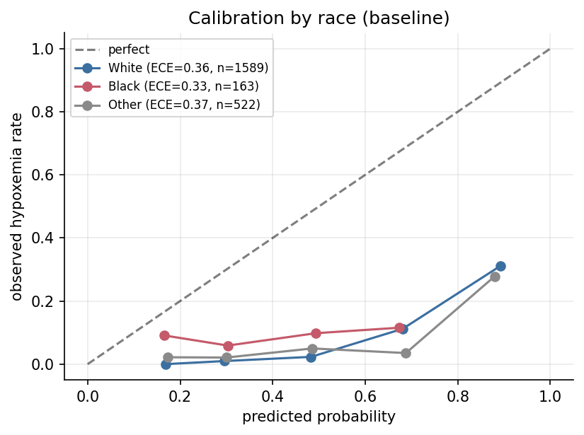
Figure 7. Calibration by race. The curves are similar across groups, so there is no calibration gap. The overall miscalibration comes from class balanced training.

5. Discussion

5.1 Main finding
We asked whether the known racial bias of pulse oximetry appears in real ICU data, whether it compounds across the intersection of race and sex, and whether it carries over into a machine learning risk model that can be made fairer. The method paired arterial SaO2 with the nearest SpO2 reading, measured occult hypoxemia across subgroups, and then trained a class balanced logistic regression baseline together with a race blind adversarial model. The clearest finding sits at the device level. Occult hypoxemia was about three times more common in Black than in White patients, and this held for both women and men. A model that relies on SpO2 took on this bias, and enriching the feature set with unbiased vitals was the single change that reduced the gap the most.

5.2 Interpretation of the results
The most likely reason the model inherited the bias is simple. When SpO2 is the main informative feature, the model has little choice but to trust it, so it repeats the exact error the device makes on darker skin. This reading is supported directly by the results, because adding unbiased vitals cut the gap while training tricks alone did not. The weak absolute calibration is best explained by the class balanced training, which shifts predicted probabilities upward to compensate for the low prevalence of hypoxemia. This is expected behaviour rather than a bug, and it does not affect the ranking based AUC or the threshold based false negative rate. The remaining possibility, that the subgroup differences at the model level reflect real group specific behaviour, cannot be confirmed here because the number of events per subgroup is small. We treat that part as a hypothesis and not as a proven effect.

5.3 Comparison with the baseline
The comparison should not rest on a single number. In discrimination the enriched adversarial model reached an AUC of 0.820 against 0.762 for the thin baseline, a real but modest gain. The more meaningful difference is in fairness, where the Black to White false negative gap fell from 0.12 for the thin baseline to 0.06 for the adversarial model and to 0.04 once vitals were added. Both models are cheap to run and train in a few seconds on a laptop, so there is no practical cost in time. The baseline keeps an advantage in transparency, since logistic regression coefficients are easy to read while the adversarial network is harder to explain. On the rare and high risk subgroups, which is where fairness actually matters, the enriched and adversarial models did better than the thin baseline. Taken together the added complexity is justified mainly by the fairness gain and not by raw accuracy.

5.4 Which errors matter most
This task carries a clear asymmetry in the cost of errors. A false positive means flagging a patient who is not truly hypoxemic, which leads to an extra blood gas draw and a small burden. A false negative means missing a patient who is truly hypoxemic, which can delay oxygen therapy and cause real harm. In a screening setting the false negative is the dangerous error, so recall on the truly hypoxemic patients matters more than precision. This is why the false negative rate, broken down by race, is the metric we lead with. It also frames the fairness problem correctly, because the concern is not that the model is wrong on average but that it is more likely to miss the dangerous cases in one group than in another.

5.5 Comparison with the literature
The device level result agrees closely with earlier work, and this agreement is informative rather than a coincidence. Our Black versus White occult hypoxemia rate of 11.3% against 3.2% is very close to the 11.4% against 3.6% reported by Sjoding et al. on different hospitals, which suggests the bias is a property of the technology and not of one dataset. Our estimate is not identical to every study, and the differences are easy to explain. Valbuena et al. reported higher absolute rates because their population was general inpatients rather than ICU patients, and Wong et al. worked on a far larger multicenter group of patients. These studies used different datasets, splits and populations, so we do not claim that any model here is better than theirs. What our work adds on top of this literature is the intersectional view across race and sex, a direct demonstration that the bias spreads into a model, and a mitigation that does not use race at decision time.

5.6 Error analysis
To understand where the baseline fails we looked at the truly hypoxemic patients in the test set and split them into the cases the model caught and the cases it missed. Three patterns stand out, and all three are visible in Figure 8.
The first pattern is that the misses are exactly the occult cases. The missed patients had a median device over-read (SpO2 minus SaO2) of about 16 points against about 5 points for the caught patients, and 81% of the missed patients had an SpO2 above 96, meaning a fully reassuring reading. The cause is the same reliance on SpO2 described above, and the way to reduce it is to give the model unbiased signals so a high SpO2 is no longer taken at face value.
The second pattern is a severity paradox. Most of the missed cases were not borderline, since 78% of them had an SaO2 below 85, which is severe hypoxemia. Because a reassuring SpO2 hides the depth of the desaturation, the model tends to miss the most dangerous cases rather than the mildest ones. Clinically this is the worst place to fail, and it strengthens the argument for not trusting SpO2 alone.
The third pattern is a racial gradient in the misses. The false negative rate rose from 0.35 in White patients to 0.47 in Black patients and 0.52 in the Other group, which is consistent with the larger device over-read in patients with darker skin. This gradient rests on small subgroup counts, so we read it as directional support for the main story rather than as an independent significant result.
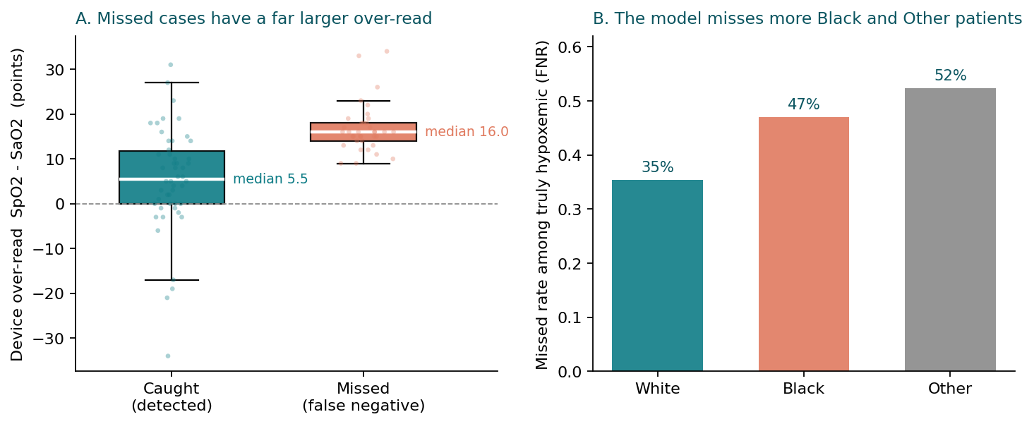
Figure 8. Error analysis of the baseline. Left, the missed cases (false negatives) have a much larger device over-read than the caught cases. Right, the miss rate among truly hypoxemic patients rises from White to Black to Other.

5.7 Statistical versus clinical significance
It helps to separate two questions that are easy to confuse. The statistical question is whether an observed difference is larger than the noise we would expect. By that test the device level bias is clearly significant, since it rests on thousands of readings with p below 0.001, while the model level false negative gap is not significant, since it rests on a handful of events per subgroup and its bootstrap interval crosses zero. The clinical question is whether a difference is large enough to change a decision, a treatment or patient safety. Even a modest reduction in missed severe hypoxemia could matter clinically, because each missed case can delay oxygen therapy. We did not test the model inside a real clinical workflow, so any clinical benefit is a reasonable expectation and not something we measured, and we state that openly.

5.8 Strengths
The work has several strengths. It uses a clear and objective ground truth, the arterial SaO2, together with an arterial filter that removes venous samples which would otherwise inflate the apparent bias. It reproduces the magnitude reported in the published literature, which is a strong check that the pipeline is correct. It analyses two levels, the device and the model, and reports honestly that the device finding is solid while the model finding is directional. It evaluates from several angles rather than one, using AUC, false negative rate by group, bootstrap confidence intervals, per group calibration and an error analysis. Finally the whole pipeline is reproducible on a public dataset and runs on ordinary hardware, and race is used only during training and never at decision time.

5.9 Limitations
The main limitations fall into four groups, summarized in Table 3.
Data | Model | Evaluation | Ethical
Single database from one region | Simple tabular models | No external validation | Race is a coarse category
Mean blood pressure missing in 81% of pairs | The 0.5 decision threshold is arbitrary | Small subgroup event counts | Risk of automation bias if trusted blindly
Only the first 24 hours of the stay | Weak absolute calibration | Model level gap is underpowered | Uses a sensitive attribute in training
Retrospective data | Adversary sensitive to its strength | Single institution split | Skin tone is not measured directly
Table 3. Main limitations grouped by source.
The most important of these is the small subgroup event count, because it is the reason the model level gap cannot reach significance. It limits how far the model level result can be generalized, and it is the first thing a larger group of patients should fix. The missing blood pressure and the internal only evaluation limit generalizability in similar ways, and each can be addressed with more data and an external source.

5.10 Generalizability and external validation
The model was validated only on a held out test set from MIMIC-IV, so its performance on other settings is untested. A test set from the same database is not enough on its own, because it shares the same hospitals, devices, recording practices and population, so it can hide a shift that would appear elsewhere. Proper external validation would use a different source such as eICU, a different institution, a different mix of devices, or a different time period, and would report whether performance drops and whether any domain shift appears. We list this as a clear limitation and as the natural next step.

5.11 Bias and subgroup analysis
Unlike many studies that report only an average score, subgroup analysis is central to this work, since the whole question is about fairness across race and the intersection of race and sex. We did not break the results down by other axes such as age, illness severity, language, institution type or device type, partly because device identifiers are not available in the data. We are careful not to claim that the model is fair simply because its average performance is reasonable, because a good average can still hide a worse false negative rate in one group, which is exactly the effect we set out to measure.

6. Future work
Several directions follow directly from the limitations and findings. First, a larger group of patients that uses the full ICU stay rather than only the first 24 hours would give the subgroup analysis the statistical power it currently lacks. Second, external validation on a separate source such as eICU would test whether the results hold beyond MIMIC-IV. Third, post hoc calibration would fix the weak absolute probabilities without changing the ranking. Fourth, if skin tone or device metadata become available, they would let the analysis move beyond race as a coarse category toward the underlying physical cause. Fifth, an ablation on the adversary strength and on which vitals carry the signal would clarify what is actually driving the fairness gain. Sixth, a prospective or workflow oriented evaluation would test whether a fairer model changes real decisions and outcomes rather than only offline metrics.

7. Conclusion
The results indicate that a simple and very common device, the pulse oximeter, carries a measurable racial and intersectional bias that hides dangerous hypoxemia more often in Black patients, and that this bias can spread into a clinical machine learning model that relies on it. The study demonstrates the feasibility of reducing that gap by enriching the model with unbiased physiological signals and adding a race blind adversarial component, while keeping accuracy and running on ordinary hardware. The device level evidence is strong, while the model level fairness gap is directional and rests on small subgroups, so these findings are best read as preliminary. Further validation on external data and on a larger group of patients is needed before any clinical use. Even so, the work points toward a practical and fairer approach to clinical decision support.

References
[1] Sjoding MW, Dickson RP, Iwashyna TJ, Gay SE, Valley TS. Racial Bias in Pulse Oximetry Measurement. N Engl J Med. 2020. 383(25). 2477 to 2478.
[2] Wong AI, Charpignon M, Kim H, et al. Analysis of Discrepancies Between Pulse Oximetry and Arterial Oxygen Saturation Measurements by Race and Ethnicity and Association With Organ Dysfunction and Mortality. JAMA Netw Open. 2021. 4(11). e2131674.
[3] Valbuena VSM, Seelye S, Sjoding MW, et al. Racial bias and reproducibility in pulse oximetry among medical and surgical inpatients in general care in the Veterans Health Administration 2013 to 2019. BMJ. 2022. 378. e069775.
[4] Racial and Ethnic Disparities in Occult Hypoxemia Prevalence and Clinical Outcomes. A Systematic Review and Meta-analysis. J Gen Intern Med. 2024.
[5] Racial Disparities in Pulse Oximetry Cannot Be Fixed With Race-Based Correction. arXiv 2210.04990. 2022.
[6] Obermeyer Z, Powers B, Vogeli C, Mullainathan S. Dissecting racial bias in an algorithm used to manage the health of populations. Science. 2019. 366(6464). 447 to 453.
[7] Zhang BH, Lemoine B, Mitchell M. Mitigating Unwanted Biases with Adversarial Learning. AAAI/ACM Conference on AI, Ethics, and Society (AIES). 2018.
[8] Johnson AEW, Bulgarelli L, Shen L, et al. MIMIC-IV, a freely accessible electronic health record dataset. Sci Data. 2023. 10. 1.

